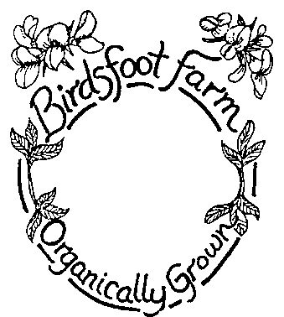
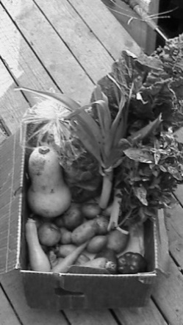
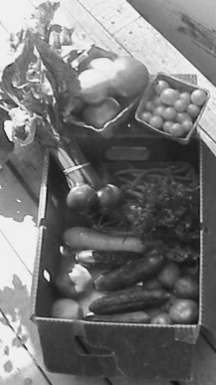
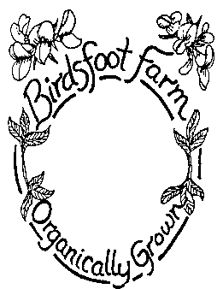
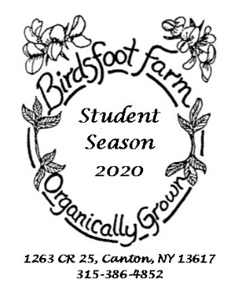
birdsfootfarm@gmail.com
http://birdsftootfarm.weebly.com
Student CSA
Fall 2023
1263 CR 25, Canton, NY 13617
315-386-4852
Dear interested student.
We would like to offer you fresh certified organic local veggies and herbs. Our student share has in mind that you have different timing than our regular CSA.
The weekly share starts August 30, with a mix of summer veggies until Dec.7. There are no veggies for fall break and Thanksgiving break.
A typical September box would have:
2lb potatoes, 1lb carrots, 1 lettuce, 2 zucchinis, 1 summer squash, 1-2 cucumbers, 2-3lb tomatoes, 1lb beans, 2 garlic, 1 bunch of herbs, later on there would be kale, winter squash…$
A typical November, December box would have:
2lb of potatoes, 1lbs of carrots,, 1 garlic, 1/2lb of parsnips, 1/4lb of celeriac, 1/2lb of beets and any greens still not counting fall break and Thanksgiving week.
The total for the student fall share is $380, ($10 discount if paid in full in May.)
Boxes will be given out weekly as you may not have much storage ability. Please rotate boxes back every week.
We hope that you enjoy the fresh veggies direct from the farm to you,
Peace, Dulli

CSA Membership Contact Information

Name:___________________________________________

Address:___________________________________________
Email:___________________________________________
Phone:___________________________________________
1263 CR 25, Canton, NY 13617
315-386-4852
Sign Me Up
Student Share: $380+ $15 for deliveries=$395
Extras:
____1/2 lb Mixed Greens: 8 wks (in place of lettuce) - $25/season
____Flowers - 4weeks $28
____Extra Leafy: 7 weeks (spinach, kale, chard) - $49

Pick-up Location
____In Canton on Tuesdays, at the Green House porch or the Canton Farmers Market starting 8/27, ending 12/5, with no box for fall break or Thanksgiving break
____In Potsdam on Fridays, starting 8/30, ending 12/8, with no box for fall break or Thanksgiving break

____At Birdsfoot Farm on ____Tuesday or ____Friday

Total: share price: $380_+ extras $_____+ $_____+$15 delivery =$______

Payment Schedule:
Early bird discount: if paid in full by May 15th, subtract $10

Member Agreement:
Members of the CSA will receive a weekly share with 7-12 items. The share will vary in size and weight depending on the time of the season. One aspect of CSA is that members support their farmer by sharing the risks (poor weather, drought, disease, early frost, crop failure, etc.) and rewards (the bounty from a good season) involved in farming. Birdsfoot uses techniques that protect the harvest such as growing a wide variety of crops that thrive in different conditions and using crop rotation to avoid disease. We also cover crops to protect against pests and to extend the growing season, cover crop over the winter, and irrigate in dry times. If there is still a crop failure of one crop, it will be substituted with another crop of similar value. If there is a total crop failure, the members will not be expected to pay for the season. The goal is to build a relationship of trust between the members and the farmer. On the whole, members will get a variety of vegetables in plentiful amounts. There is no guarantee of the exact amounts or types of produce the members will receive in their shares. By participating in the CSA, members are supporting their local farmers as well as helping to create a more environmentally just, economically fair and healthy society.

If a share is not picked up by a member it will be donated to another family or the Canton Neighborhood Center. Shares will not be saved for members unless an arrangement has been made.

Member Signature _______________________________________________ Date ________

Please make checks payable to Birdsfoot Farm and mail to 1263 CR25, Canton, NY 13617

