How to Cook Bok Choy
Jessica Gavin
Published on January 29, 2020
Jump to Recipe
Learn how to cook bok choy using a simple stir-fry method to create beautifully browned edges and crisp-tender stalks. This cabbage-like green is a popular vegetable in Asian cuisine that makes for a quick and healthy side.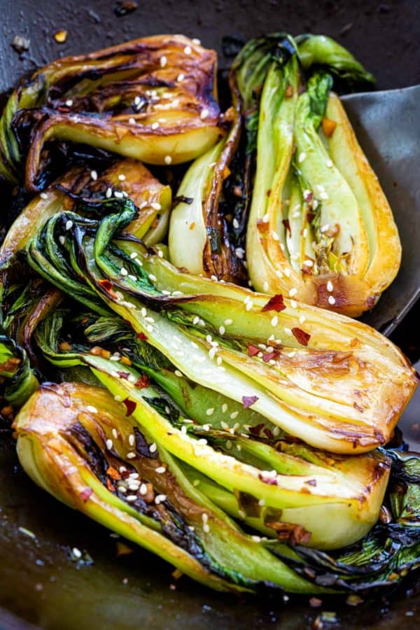
Bok choy or Chinese white cabbage (brassica rapa spp. chinensis) is a staple ingredient in Asian dishes. The tender dark green leaves and crisp off-white-colored stalks provide a nice fresh crunch. The greens have a spinach-like taste with a very mild bitterness.
You can purchase bok choy in typically two sizes, baby and large mature stalks that’ll need to be chopped into smaller pieces. Although the leaves can be eaten raw and tossed into fresh salads, there are improved taste benefits when cooking the entire vegetable.
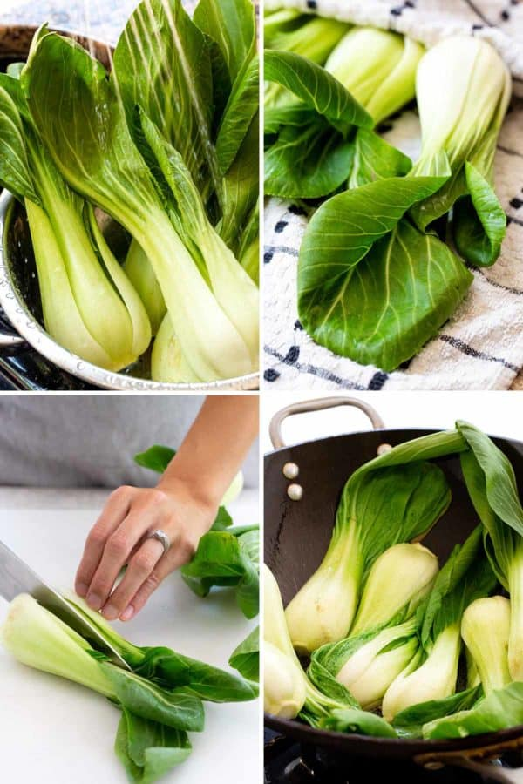

Selection and storage
Look for bok choy with bright green leaves with no wilting. The stalks should be very firm and off-white in color (or pale yellow depending on variety) with no brown spots. You can store them inside a loosely closed plastic bag in the refrigerator for up to 3 to 5 days. Wait to wash until you’re ready to cook.

Preparing large bok choy
When working with the larger varieties, wash and thoroughly dry the leaves and stems. Start by cutting away the leafy green sections and stack them on top of each other. Then cut crosswise into thin strips.
Cut the stalks into small pieces, about ½ to 1-inch in size while discarding the root portion about 1-inch from the bottom. They can now be tossed into soups, stews, or a stir-fry at the end of cooking.

Preparing baby bok choy
Baby bok choy can be eaten whole or cut into smaller portions. Start by adding them to a large bowl of cold water and plunge a few times to remove any excess dirt. You can also rinse under running water.
Shake off excess moisture and thoroughly dry the exteriors. If cutting bok choy in half after washing, make sure the inside is dry too, especially if sauteing or stir-frying. Whole portions are great for braises or stews.
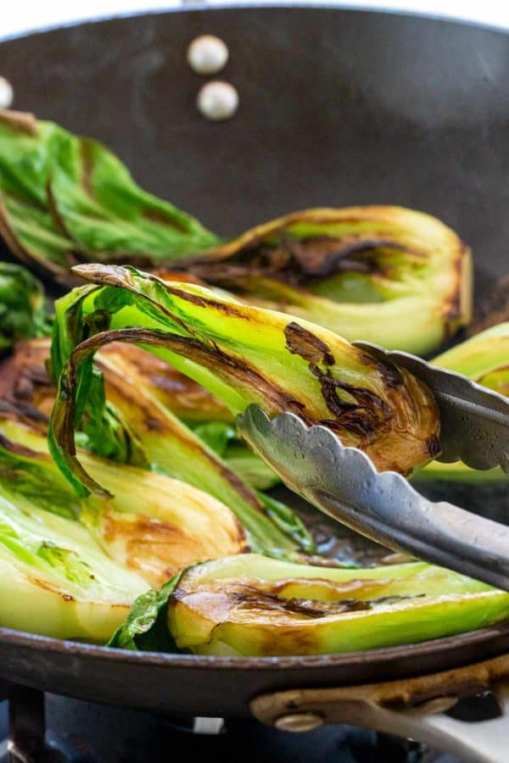

How to cook bok choy
There are various ways to cook bok choy such as steaming, braising (like with clay pots) and simmering. However, these can easily overcook the stems and create a mushy consistency. It’s important to stop cooking when the stalks are just tender, about 5 to 8 minutes, depending on the method and size of the vegetable.
I prefer the dry-heat methods like stir-frying and sauteing as they create the best contrast of texture while the browning process adds a new dimension of flavor. This allows bok choy to truly shine. Whole pieces of baby bok choy or halves cook in about 5 to 7 minutes. Smaller chopped pieces used in a stir fry can take 2 to 3 minutes to tenderize.
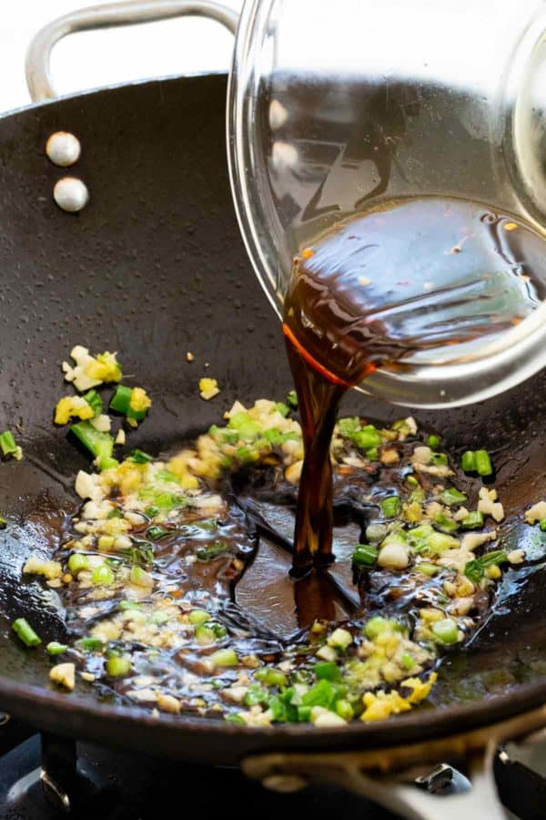

Stir-fry to maximize the flavor
To really get some good browning and flavor development I prefer to stir-fry baby bok choy. You can use a large wok or nonstick skillet to brown and tenderize the greens. Cut the vegetables down the center to create two halves, this gives a more stunning presentation and keeps the structure intact after cooking.
Cook the cut sections for a few minutes in hot oil in a large skillet without moving, this deepens the color on the surface. Once the color appears, flip over and cook the other side. The greens can now be stir-fried with a sauce to infuse more flavor.

Flavor boosters
Adding in aromatics and sauces creates layers of flavor. Fresh ginger, minced garlic, and sliced green onions provide instant pungency and earthiness. Cook these in vegetable oil until fragrant as they are very delicate. You want to make sure the garlic does not burn.
To further enhance the flavor a sauce is added at the very end of cooking. It’s a combination of soy sauce, vegetable broth, rice vinegar, sesame oil, honey, and chili flakes. When stir-fried with seared bok choy it creates delicious glazed halves.
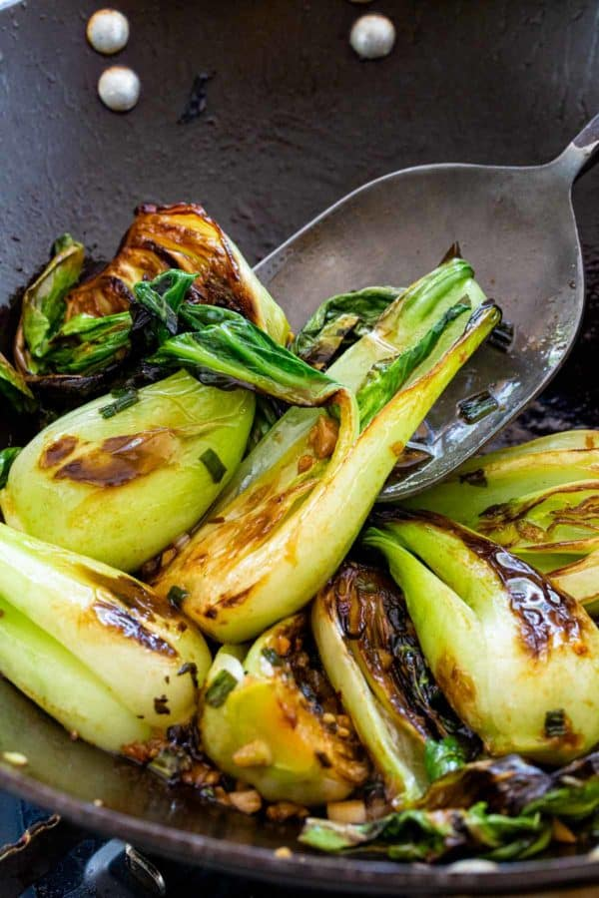

Ways to use bok choy
- Stir-fried with noodles like lo mein.
- Add whole into soups like wonton soup.
- Braise in dishes like a buddhas clay pot.
- Chop or use baby bok choy to pair with a protein and sauce in a stir fry.

Don’t move the bok choy!
To ensure a deep golden sear on the surface, it’s important to place the cut side down first. Do not be tempted to lift or move the vegetable around in the pan. Give it a few minutes before flipping. The combination of hot oil, high heat and direct contact with the cooking surface will develop a stunning light char with toasted nutty notes.
Pin this recipe to save for later
Pin This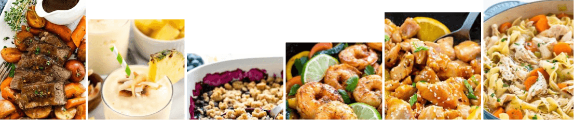

How to Cook Bok Choy
Learn how to cook bok choy, a healthy Asian vegetable, using the stir-fry method to create beautifully browned edges and crisp-tender stalks.

Pin Print
Review
3.85 from 57 votes
Prep Time10 mins
Cook Time7 mins
Total Time17 mins
Servings 4 servings
Course Side
Cuisine Asian

Ingredients
- ▢ 1 pound baby bok choy
- ▢ 2 tablespoon soy sauce
- ▢ 2 tablespoons vegetable broth
- ▢ 1 tablespoon rice vinegar
- ▢ 1 tablespoon sesame oil, divided
- ▢ 1 teaspoon honey
- ▢ ⅛ teaspoon red chili flakes
- ▢ 2 tablespoons vegetable oil, divided
- ▢ 1 tablespoon minced garlic
- ▢ 2 teaspoons minced ginger
- ▢ ¼ cup thinly sliced green onions, white and green parts
- ▢ ¼ teaspoon sesame seeds

Instructions
- Rinse the bok choy with water. Shaking off any excess water and then dry using a kitchen towel or paper towels.
- Cut each bok choy, halved lengthwise.
- In a small bowl combine soy sauce, broth, vinegar, 2 teaspoons of sesame oil, honey, and red chili flakes.
- In a wok or 12-inch nonstick skillet add 1 tablespoon vegetable oil and 1 teaspoon of sesame oil over high heat until just smoking.
- Use tongs to carefully place the bok choy cut side down in a single layer in the wok, lightly press down to make contact with the surface.
- Cook until lightly browned without moving, about 1 to 2 minutes.
- Flip the bok choy over and cook the other side until lightly browned, 1 to 2 minutes. Transfer to a plate.
- Add 1 tablespoon vegetable oil to the wok. Add garlic, ginger and green onions, stir fry until fragrant, about 30 seconds.
- Add the soy sauce mixture to the wok, simmer until thickened, about 30 seconds.
- Add bok choy back to the wok, stir-fry and cook until the sauce glazes the greens, about 1 to 2 minutes.
- Transfer to a platter and garnish with sesame seeds.

Equipment
- Wok
- Wok Spatula
- Colander

Notes
- Make it Gluten-Free: Use coconut aminos, or gluten-free tamari instead of soy sauce.
- Make it Paleo: Use coconut aminos instead of soy sauce, olive oil instead of vegetable oil, and maple syrup instead of honey.

