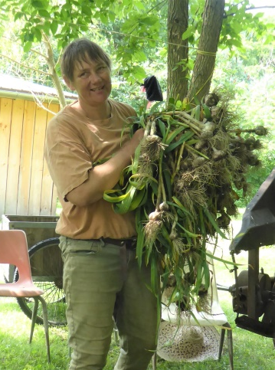  Farming for you | Summer  Season  2023  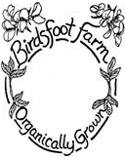  1263 CR 25, Canton  NY 13617  315-386-4852  birdsfootfarm@gmail.com  http://birdsftootfarm.weebly.com | 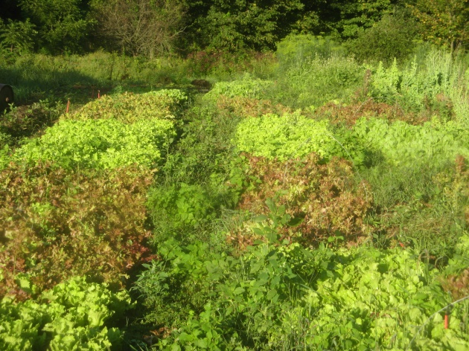  In the field

Dear CSA interested friend:

Birdsfoot Farm has been growing certified organic vegetables, flowers, and herbs for over 50 years. In addition to our lively CSA we also sell at the Canton Farmers Market, the Potsdam Food Coop, Natures Storehouse and Nori’s in Saranac Lake. Birdsfoot Farm is an intentional community of seven adults and two children. The Veggie Business is set up as a partnership with seasonal workers that grow the freshest, high quality local food for you.
What is a CSA?
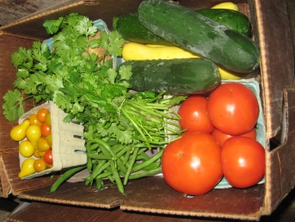
CSA is a commitment from the grower to provide in-season vegetables to the members. Members pay the farmer up front, or in an installment plan, and pick up vegetables weekly. (We do accept food stamps.) The benefit to the farmer is a guaranteed market and a personal connection to the members. In return, the member receives the freshest, local, in-season, certified organic vegetables and herbs, our bi-weekly popular newsletter and a relationship with the farmer. If there is a shortage of a crop, other crops of the same value may be substituted. If there is an overflow, members might get extra. There may also be larger quantities for freezing and canning at wholesale prices.
“Farmer Support price” will help to give $1/hr. extra to the farmer.
Discounts:
Staff of St. Lawrence Health Systems qualifies for a $100/share discount, a cost share program funded by SHLS. Please note on your application form.
For income eligible households, sign up for Bonus Bucks via the local non-profit GardenShare, to receive 50% off the full share price (or up to $250).
Don't worry about what to cook for dinner; the answer lies in your box. This year we plan to have 60 members.

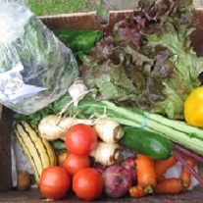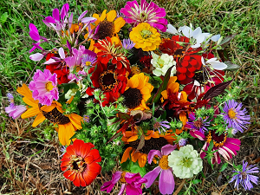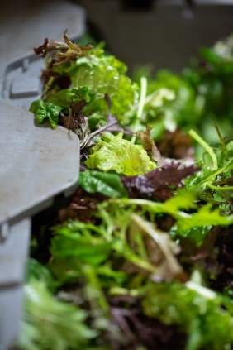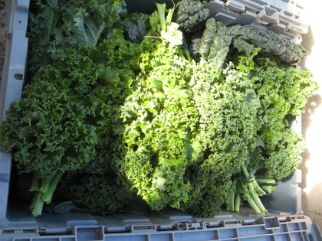
Fall share Flower share Mixed Greens share Extra Leafy share

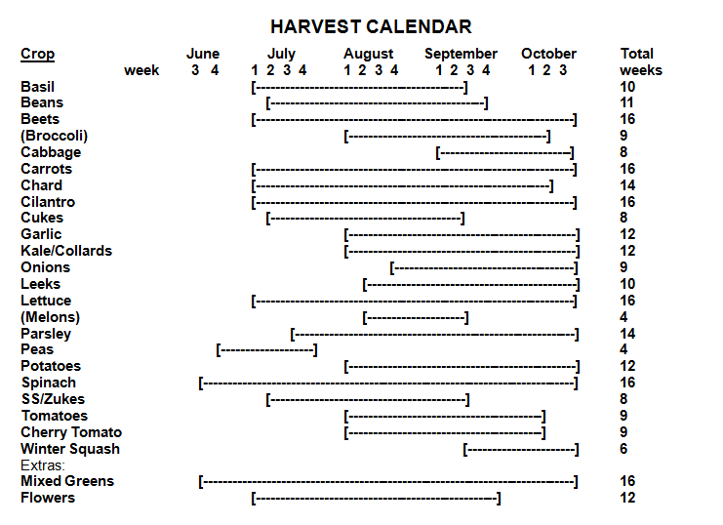

Looking forward:

Fall CSA share Oct.17-Dec.19; Winter CSA share Jan.2-March 2, 2024

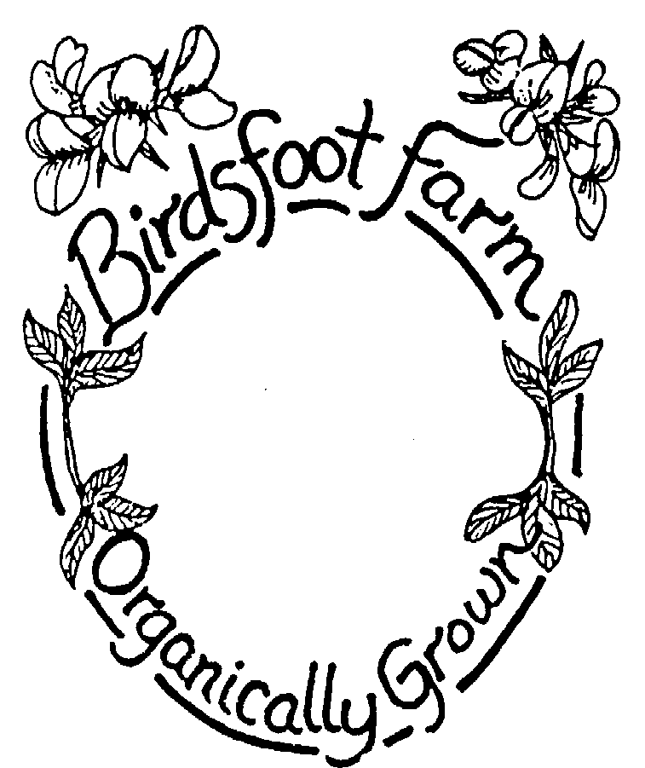
A personal note: For me, farming is a passion. Sometimes it is repetitious and tiresome but there is always something new to learn and I feel in harmony with the soil and plants. Farming is a way of living. Farming grows good food for people and is a service to the greater community, as well as a source of income that provides opportunities for generations to come. –Dulli
CSA Membership Contact Information
Summer
Season
2023

2012

Name:___________________________________________

Address:___________________________________________
Email:___________________________________________
Phone:___________________________________________
Sign me up
1263 CR 25, Canton, NY 13617
315-386-4852

“Farmer support price “will help give farmer $1/hr. extra income
Share size: 18 weeks
__Single/Couple share – $522/ ($580 farmer support) season
A typical box in August would have: 2lb potatoes, 1lb carrots, 1 lettuce, 2 zucchinis, and beets/kale/chard
2 summer squash, 4 cukes, 2-3lb tomatoes, pepper, 1lb beans, 2 garlic, 1-2 bunches of herbs, last peas

__Family/Group share – $1000/ ($1100 farmer support) season
Box contains twice the amounts above

__Student-Share: $380 August 31-December 14; except fall break and Thanksgiving break

Extras:
__1/2 lb. Mixed Greens, a Birdsfoot specialty: 18 wks. (In place of lettuce) - $58/season

__Flowers, treat yourself to a weekly bouquet of flowers (14+ weeks) - $110/season

Some people cannot get enough leafy greens:
__Extra Leafy: spinach or kale or chard and lettuce - $125
Extra lettuce and a bunch of spinach, chard, kale, or collards – mid June through mid-September – 16 weeks

Schedule and Pick-up Location
__In Canton on Tuesdays, starting 6/13, ending 10/10
__In Potsdam on Fridays, starting 6/16, ending 10/13
__At Birdsfoot Farm on ____Tuesday or ____Friday

__$27 season delivery charge – Canton and Potsdam pick-ups.

Total: share price $______+ extras $_____+ $_____+ $27delivery+ $_____ farmer support =$______
.
Payment Schedule:
____I would like to pay the entire amount by April 30
____I would like to pay half by April 30 and the other half by August 30
____I would like to pay with food stamps, beginning either Tuesday June 14 or Friday June 17 at the Canton Market through Garden Share
Late fee +$10 if paid after April 30th (except food stamp payment)

Please make checks payable to Birdsfoot Farm and mail to 1263 CR25, Canton, NY 13617

Member Agreement:
Members of the CSA will receive a weekly share with 7-12 items. The share will vary in size and weight depending on the time of the season. One aspect of CSA is that members support their farmer by sharing the risks (poor weather, drought, disease, early frost, crop failure, etc.) and rewards (the bounty from a good season) involved in farming. Birdsfoot uses techniques that protect the harvest such as growing a wide variety of crops that thrive in different conditions and using crop rotation to avoid disease. We also cover crops to protect against pests and to extend the growing season, cover crop over the winter, and irrigate in dry times. If there is still a crop failure of one crop, it will be substituted with another crop of similar value. If there is a total crop failure, the members will not be expected to pay for the season. The goal is to build a relationship of trust between the members and the farmer. On the whole, members will get a variety of vegetables in plentiful amounts. There is no guarantee of the exact amounts or types of produce the members will receive in their shares. By participating in the CSA, members are supporting their local farmers as well as helping to create a more environmentally just, economically fair and healthy society.

The share costs are for growing food. This year there is no membership or administrative fee. There is a charge for delivery to Potsdam and Canton that cannot be paid with food stamps and will be charged separately for members paying with food stamps.

If a share is not picked up by a member it will be donated to another family or the Canton Neighborhood Center. Shares will not be saved for members unless an arrangement has been made.

Member Signature _______________________________________________ Date ________________

Questionnaire (optional)
1. How many in your family? Adults _____ Children (age) _____ _____ _____ _____
2. How often do you eat out? ________________________________________________________________
3. Do you have a garden? ______ What do you grow? ____________________________________________________________________________________________________________________________________________________________________________
4. What vegetables or herbs are favorites in your house?__________________________________________
______________________________________________________________________________________
5. What vegetables could you do without?____________________________________________________
6. Do you have any allergies or other food issues? _____________________________________________
7. If you freeze or can food for the winter please check the items below that you might want to buy in bulk.
We will contact you if any bulk items become available.
___tomatoes ___spinach ___basil ___beans ___cucumbers ___other, please specify ___________________
9. Other comments, requests, questions, concerns: ______________________________________________
10. I am interested in Fall CSA share Oct.18-Dec20; Winter CSA share Jan3-Feb. 28, 2024 share
Fall:___yes, ___no,__maybe Winter: :___yes, ___no,__maybe

