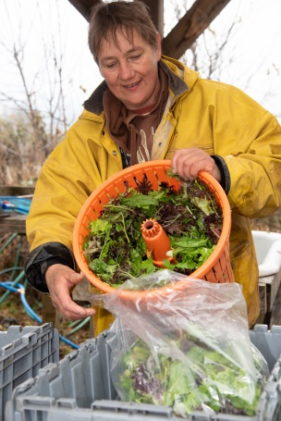  Farming for you | Summer  Season  2020  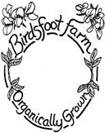  1263 CR 25, Canton  NY 13617  315-386-4852  birdsfootfarm@gmail.com  http://birdsftootfarm.weebly.com | 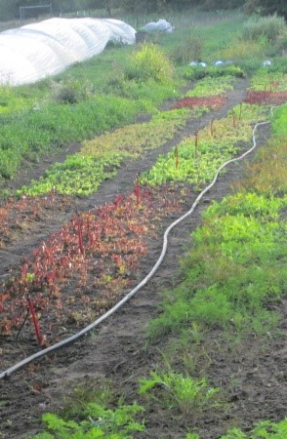  In the field

Dear CSA interested friend:

Birdsfoot Farm has been growing certified organic vegetables, flowers, and herbs for over 40 years. In addition to our lively CSA we also sell at the Canton Farmers Market, the Potsdam Food Coop, Natures Storehouse and North Country Grown Cooperative. Birdsfoot Farm is an intentional community of eight adults and three children. The Veggie Business is set up as a partnership with seasonal workers that grow the freshest, high quality local food for you.
What is a CSA?
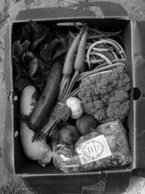
CSA is a commitment from the grower to provide in-season vegetables to the members. Members pay the farmer up front, or in an installment plan, and pick up vegetables weekly. (We do accept food stamps.) The benefit to the farmer is a guaranteed market and a connection to the customer. In return, the member receives fresh, local, in-season, certified organic vegetables and herbs and a relationship with the farmer. If there is a shortage of a crop, other crops of the same value may be substituted. If there is an overflow, members might get extra. There may also be larger quantities for freezing and canning at wholesale prices.
November through January we offer the winter-share with six pickups, every two weeks.
If you are interested in supporting your local farmer, contact us. Don't worry about what to cook for dinner; the answer lies in your box. This year we plan to have 60 members.
A personal note: For me, farming is a passion. Sometimes it is repetitious and tiresome but there is always something new to learn and I feel in harmony with the soil and plants. Farming is a way of living. Farming grows good food for people and is a service to the greater community, as well as a source of income that provides opportunities for generations to come. –Dulli

CSA schedule - Share sizes – Prices 2020
“Single/Couple” Share : $440 for 18 weeks ($24.44/week)
A typical box in August would have: 2-3lb potatoes, 1lb carrots, 1 lettuce, 2 zucchinis, beets or kale or chard,
2 summer squash, 4 cukes, 2-3lb tomatoes, 1lb beans, 1 garlic, 1-2 bunches of herbs, last peas, first onions
“Family/Group” Share : $850 for 18 weeks ($47.22/week)
Box contains twice the amounts above.
“Student”-Share: $310 August 28-December 11; fall break and Thanksgiving break considered
Extras for those who want more:
Our mixed greens are a Birdsfoot specialty
Mixed Greens - $58.00
1/2lb of fancy mixed greens instead of lettuce - end of June through mid-October – 18 weeks
Some people cannot get enough leafy greens
Extra Leafy: spinach or kale or chard and lettuce - $96.00 ($6.00/week). Extra lettuce and a bunch of spinach, chard, kale, or collards – mid June through mid-September – 16 weeks
Extra Spinach and Lettuce Leafy - $98 ($7.00/week) mid-June through mid-September_ 14 weeks
Treat yourself to a beautiful bouquet of flowers
Flowers -$81( $75+$6 tax)
July through September 13-15 weeks
The CSA runs 18 weeks. Pick-up in Canton is on Tuesdays and starts June 9 . Pick-up in Potsdam is on Fridays and starts June 12. Farm pick-ups can be on either Tuesdays or Fridays.

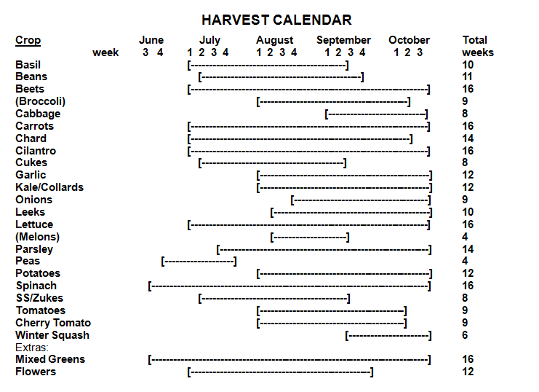
CSA Membership Contact Information
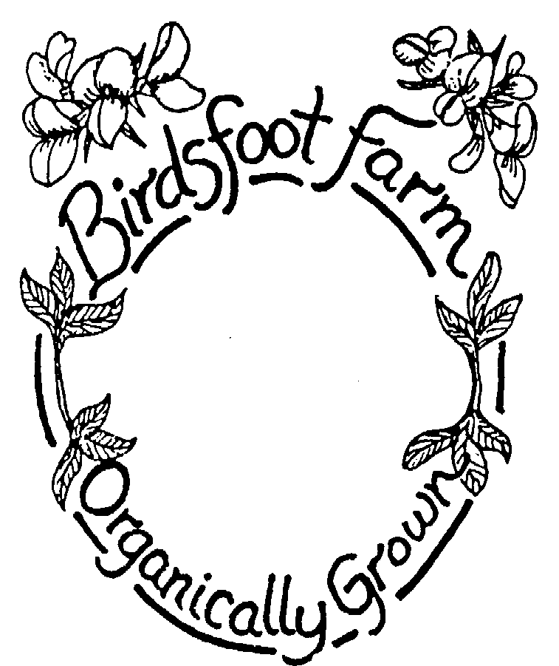
Summer
Season
Ticket
2020

2012

Name:___________________________________________

Address:___________________________________________
Email:___________________________________________
Phone:___________________________________________
1263 CR 25, Canton, NY 13617
315-386-4852
Sign Me Up
Share size: 18 weeks
____Single/Couple share – $440/season or $48.88 every 2 weeks with food stamps

____Family/Group share – $850/season or $94.44 every 2 weeks with food stamps

Extras:
____1/2 lb Mixed Greens: 18 wks (in place of lettuce) - $58/season or $6 with food stamps every 2 weeks
____Flowers - $81/season – no food stamp payment available
____Extra Leafy: 16 wks (spinach, kale, chard) $96/season or $12.00/wk with food stamps every 2 weeks
____Extra Spinach and Lettuce Leafy: 14 weeks - $98 or $14.00 every two weeks with food stamps

Pick-up Location
____In Canton on Tuesdays, starting 6/9, ending 10/8
____In Potsdam on Fridays, starting 6/12, ending 10/11
____At Birdsfoot Farm on ____Tuesday or ____Friday

____$18 season delivery charge - Canton and Potsdam pick-ups. Cannot be paid with food stamps.

Total: share price $______+ extras $_____+ $_____+ $____-+delivery charge$_____=$______

Payment Schedule:
Early bird discount: if paid in full by March 15th, subtract $10
____I would like to pay the entire amount by April 30
____I would like to pay half by April 30 and the other half by August 30
____I would like to pay with food stamps, beginning either Tuesday June 5 or Friday June 9 at the Canton Market through Garden Share)
Late fee +$10 if paid after April 30th (except food stamp payment)

Member Agreement:
Members of the CSA will receive a weekly share with 7-12 items. The share will vary in size and weight depending on the time of the season. One aspect of CSA is that members support their farmer by sharing the risks (poor weather, drought, disease, early frost, crop failure, etc.) and rewards (the bounty from a good season) involved in farming. Birdsfoot uses techniques that protect the harvest such as growing a wide variety of crops that thrive in different conditions and using crop rotation to avoid disease. We also cover crops to protect against pests and to extend the growing season, cover crop over the winter, and irrigate in dry times. If there is still a crop failure of one crop, it will be substituted with another crop of similar value. If there is a total crop failure, the members will not be expected to pay for the season. The goal is to build a relationship of trust between the members and the farmer. On the whole, members will get a variety of vegetables in plentiful amounts. There is no guarantee of the exact amounts or types of produce the members will receive in their shares. By participating in the CSA, members are supporting their local farmers as well as helping to create a more environmentally just, economically fair and healthy society.

The share costs are for growing food. This year there is no membership or administrative fee. There is a charge for delivery to Potsdam and Canton that cannot be paid with food stamps and will be charged separately for members paying with food stamps.

If a share is not picked up by a member it will be donated to another family or the Canton Neighborhood Center. Shares will not be saved for members unless an arrangement has been made.

Member Signature _______________________________________________ Date ________________
Please make checks payable to Birdsfoot Farm and mail to 1263 CR25, Canton, NY 13617
Additional (optional) opportunities to participate in the CSA and on the farm by working 3 or more hours during the season to help out with the CSA.
I would like to help with:
___ Weeding or harvest ___ Newsletter
___ Garlic festival (mid-July) ___ CSA delivery
Specific dates I could work:______________________________________________________
Newsletter
We distribute a newsletter with stories from the farm, important information and dates, and recipe ideas for our members most weeks of the CSA. Would you like to receive this newsletter over email?
Email where you'd like to receive the newsletter: ______________________________________________
Questionnaire (optional)
1. How many in your family? Adults _____ Children (age) _____ _____ _____ _____
2. How often do you eat out? ________________________________________________________________
3. How often do you eat meat? _______________________________________________________________
4. Do you have a garden? ______ What do you grow? ____________________________________________________________________________________________________________________________________________________________________________
5. What vegetables or herbs are favorites in your house?__________________________________________
______________________________________________________________________________________
6. What vegetables could you do without?____________________________________________________
7. Do you have any allergies or other food issues? _____________________________________________
8. If you freeze or can food for the winter please check the items below that you might want to buy in bulk.
We will contact you if any bulk items become available.
___tomatoes ___spinach ___basil ___beans ___cucumbers ___other, please specify ___________________
9. Other comments, requests, questions, concerns: ______________________________________________
Looking ahead – We also offer a 14 week winter CSA, starting on October 20th. We deliver bags of root vegetables every two weeks. A typical bag would include tomatoes and kale as long as they last, carrots, onions, potatoes, garlic, cabbage, beets and winter squash with an option for parsnips, and celeriac. Are you interested in the winter CSA? ______________

